# Unit Testing

## Summary

## Test 1: Logging In

**Test Result: Successful**

## Test 2: Registering as a Customer

**Test Result: Successful**

## Test 3: Tracking a Package

**Test Result: Successful**

## Test 4: Get Shipping Rates

**Test Result: Successful**

## Test 5: Booking a Package

**Test Result: Successful**

## Test 6: Logging Out

**Test Result: Successful**

## Test 7: Driver Viewing/Changing Consignment Note/Shipment Information

**Test Result: Successful**

## Test 8: Driver Logging In

**Test Result: Successful**

## Test 9: Coordinator Logging In

**Test Result: Successful**

## Test 10: Viewing Contacts

**Test Result: Successful**

## Test 11: Deleting Contacts

**Test Result: Successful**

## Test 12: Viewing Deliveries

**Test Result: Successful**

## Test 13: Send Coordinator Notification

**Test Result: Successful**

## Test 14: Send Emergency Notification

**Test Result: Successful**

## Test 15: Assign Package to Driver

**Test Result: Successful**

## Test 16: Assign Package a Delivery Date

**Test Result: Successful**

## Test 17: Assign Package Priority

**Test Result: Successful**

## Test 18: Assign Delivery a Delivery Time

**Test Result: Successful**

## Logging In

### Correct Login Details

|  |  |
| --- | --- |
| C:\Users\Matthew Magin\Downloads\screencapture-localhost-8080-dashboard-login-php-1477122997298.png | C:\Users\Matthew Magin\OneDrive\University\Year 2 - Semester 2\cab202\topic11\screencapture-localhost-8080-dashboard-login-php-1477123131716.png |
| login.php original state | login.php correct form data (credentials) entered |
| The Expected Result:  After correct form data is entered → submit button → page redirects to dashboard.php → Customer is logged in. | |

#### Output

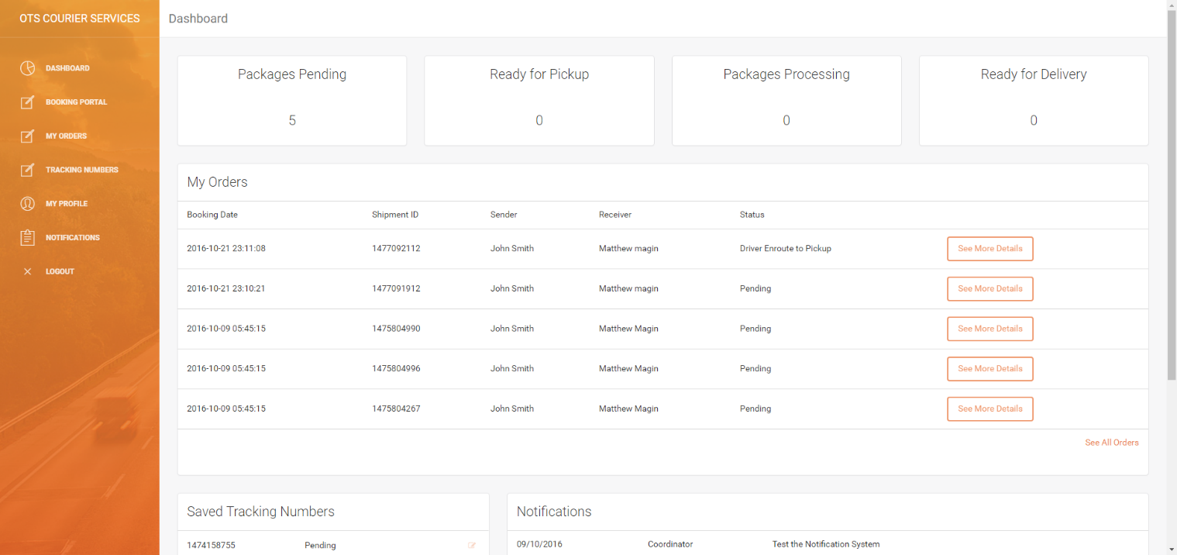

### Incorrect Login Details

|  |  |
| --- | --- |
| C:\Users\Matthew Magin\Downloads\screencapture-localhost-8080-dashboard-login-php-1477122997298.png | C:\Users\Matthew Magin\OneDrive\University\Year 2 - Semester 2\cab202\topic11\screencapture-localhost-8080-dashboard-login-php-1477125808661.png |
| login.php original state | login.php incorrect form data (credentials) entered |
| The Expected Result:  After incorrect form data is entered → submit button → page redirects to dashboard.php → Customer is logged in. | |

#### Output

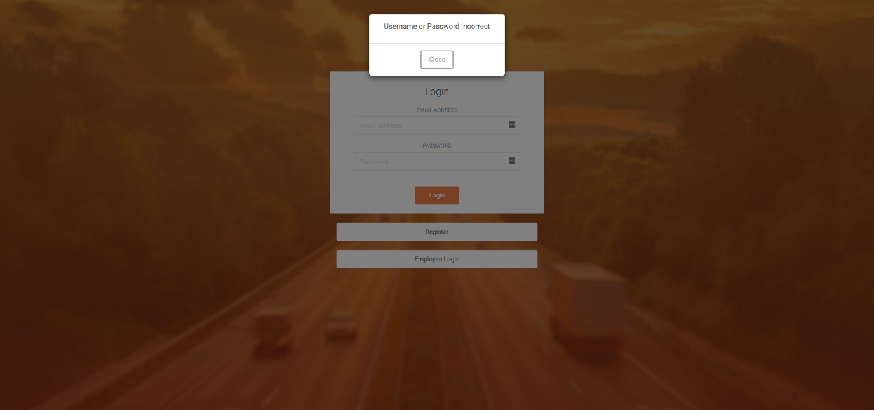

**Test Successful – The test was successful because the user was able to enter their details and login to the account. Additionally, if the user enters incorrect data the user cannot login.**

## Registering as a Customer

|  |  |
| --- | --- |
| C:\Users\Matthew Magin\OneDrive\University\Year 2 - Semester 2\cab202\topic11\screencapture-localhost-8080-dashboard-register-php-1477126151517.png | C:\Users\Matthew Magin\OneDrive\University\Year 2 - Semester 2\cab202\topic11\screencapture-localhost-8080-dashboard-register-php-1477184212273.png |
| register.php original state | register.php correct form data entered |
| The Expected Result:  After customer details are entered → submit button → page redirects to login.php → Customer can then login.  Additionally, the customers details appear in the customers table in the database Output C:\Users\Matthew Magin\OneDrive\University\Year 2 - Semester 2\cab202\topic11\screencapture-localhost-8080-dashboard-login-php-1477184345731.png | |

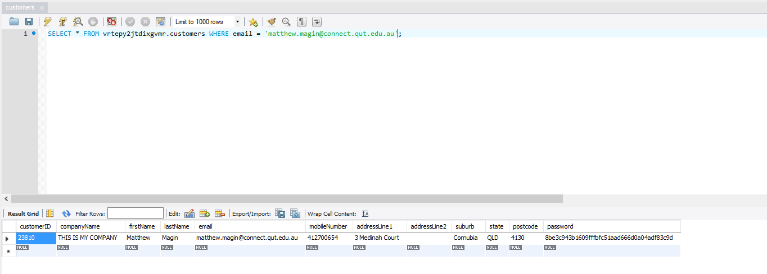

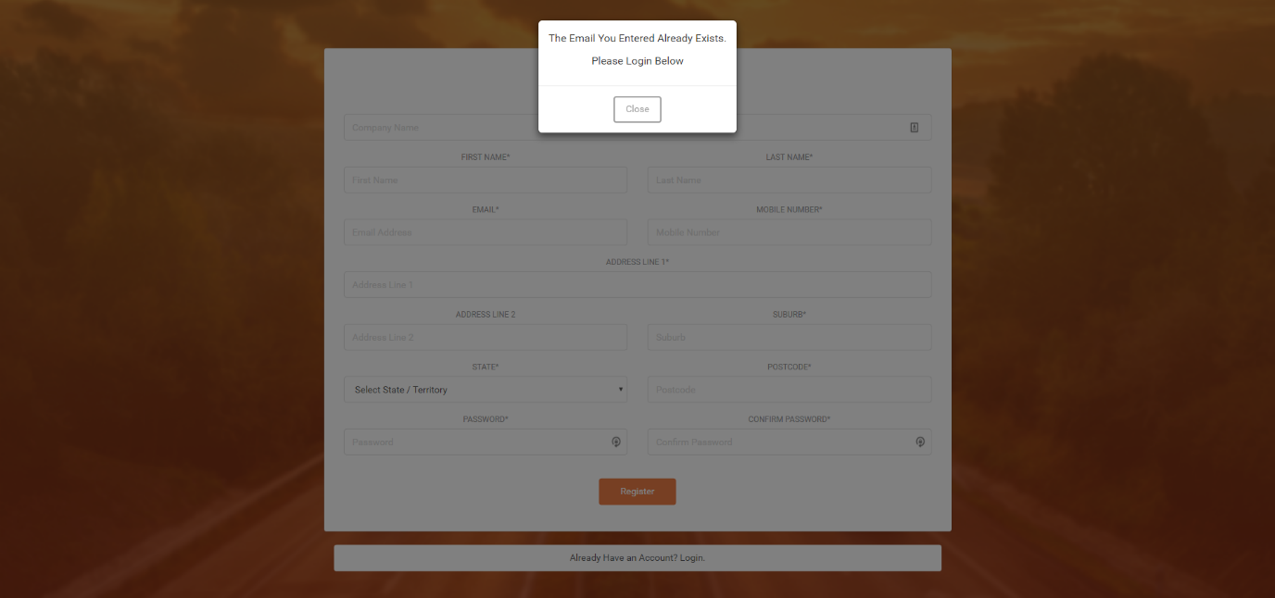

Email inputted: matthew.d.magin@gmail.com (already in the database)

**Test Successful – The test was successful because the user entered their details, click the submit button and they are redirected to the login page. And the customer’s details are saved in the database. If the email is already registered an error message appears.**

## Tracking a Package

### Tracking Number Correct

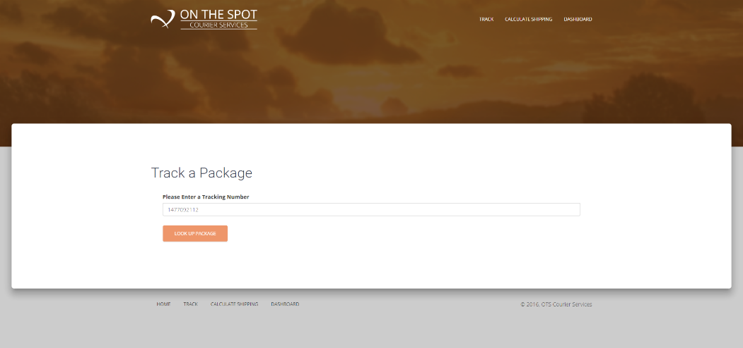

Expected Output: Tracking details are outputted to the screen

#### Output

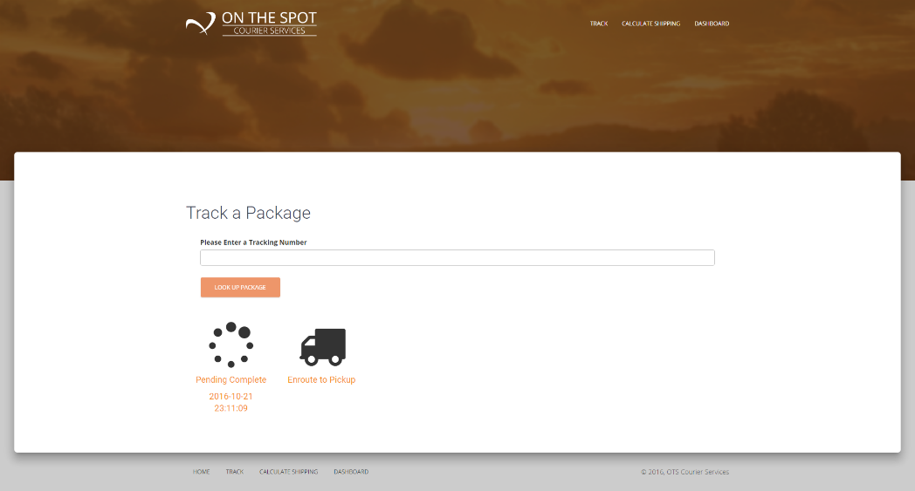

### Tracking Number Not Valid

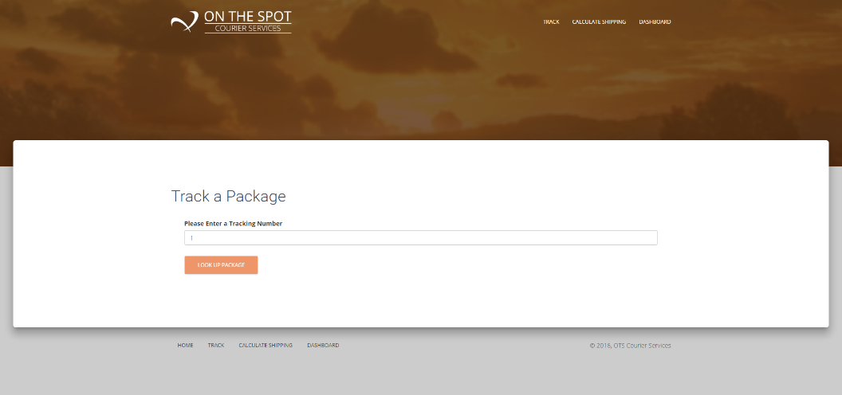

Expected Output: User is notified that the tracking number is not valid

#### Output

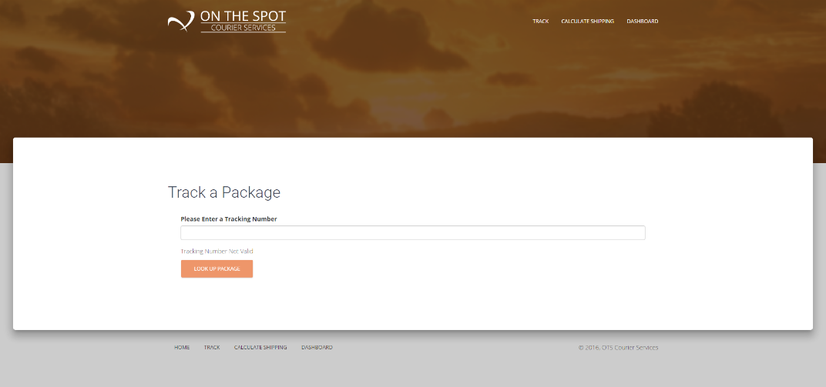

### Tracking Number Does Not Exist

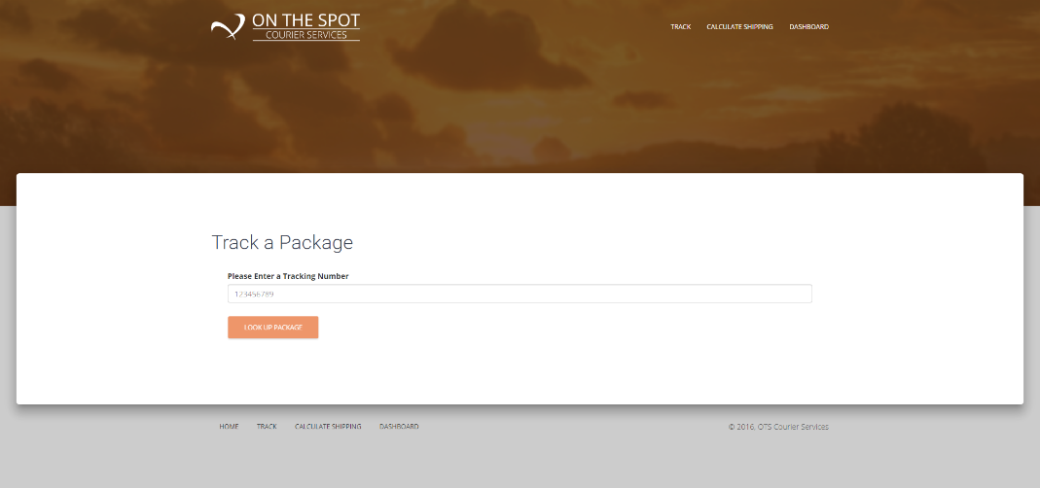

Expected Output: User is notified that the tracking number does not exist

#### Output

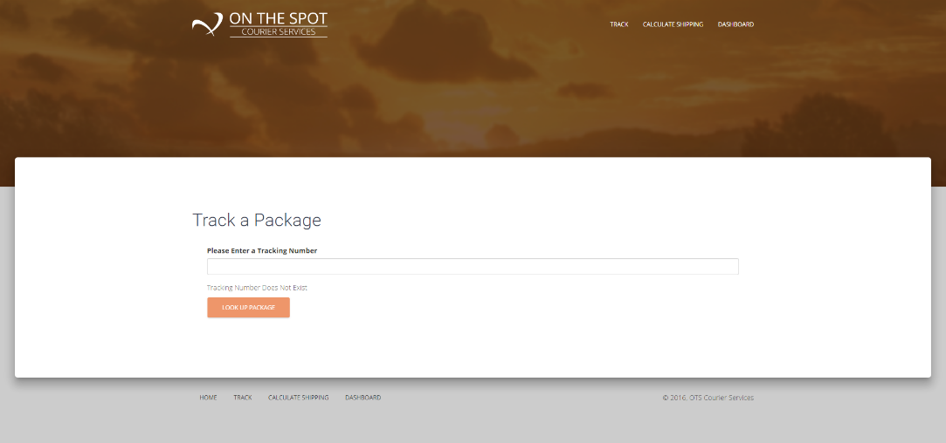

**Test Successful – The test was successful because if the correct tracking details are retrieved and displayed if the tracking number is correct. If the tracking number is not valid / incorrect an error message is displayed.**

## Get Shipping Rates

After inputting the package information in the input boxed the total cost is dynamically updated to the estimated shipping cost.

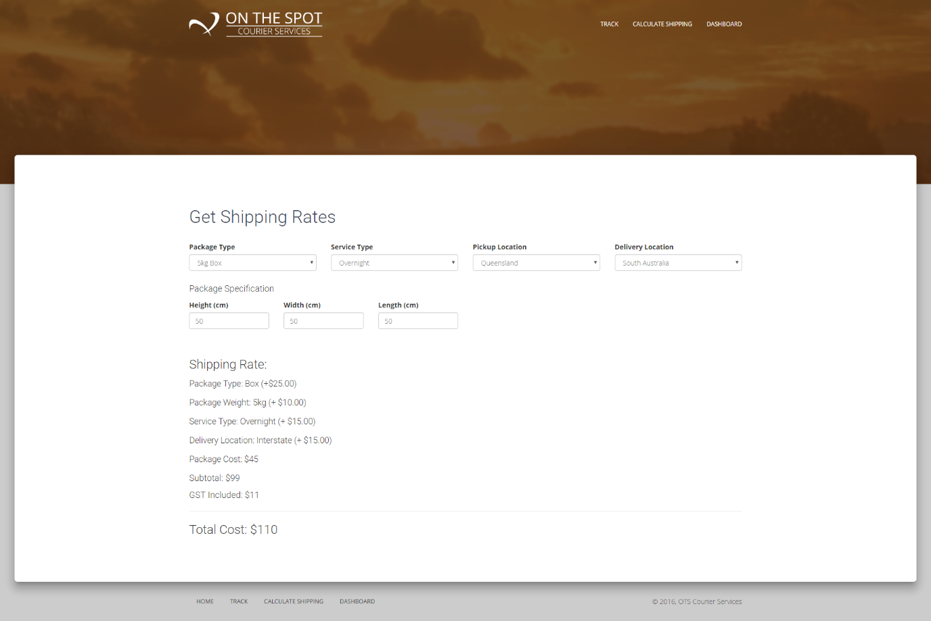

**Test Successful – The test was successful because the total cost was dynamically updated.**

## View Existing Order Details

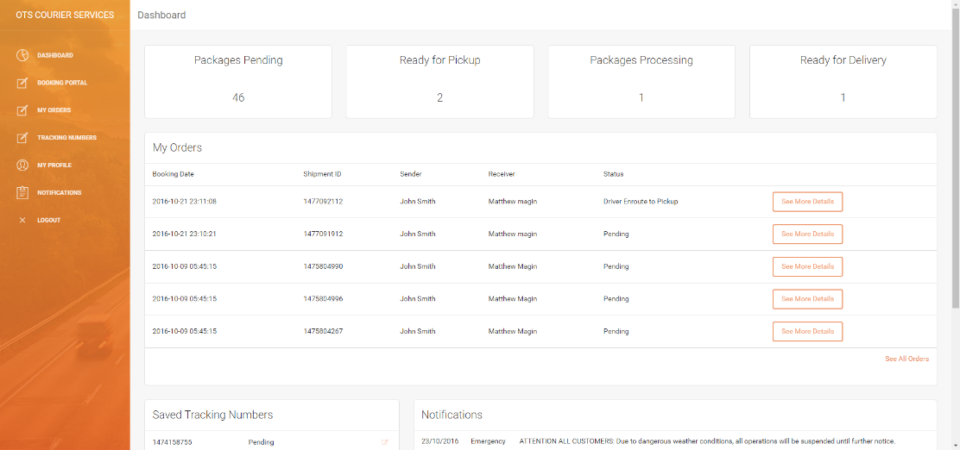

Expected action and result: On-click of the ‘see more details’ button the customer can see all details about the package, print the connote and tax invoice.

#### Output

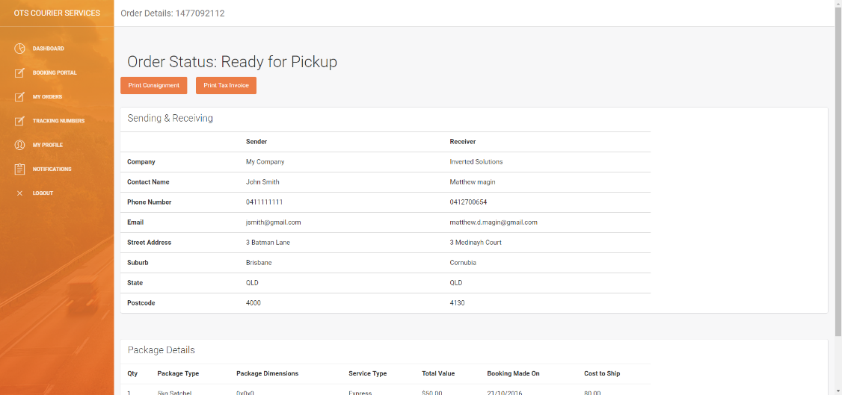

|  |  |
| --- | --- |
| C:\Users\Matthew Magin\OneDrive\University\Year 2 - Semester 2\cab202\topic11\screencapture-localhost-8080-files-taxInvoice-php-1477187752882.png | C:\Users\Matthew Magin\OneDrive\University\Year 2 - Semester 2\cab202\topic11\screencapture-localhost-8080-files-connote-php-1477187736160.png |
| Generated Prefilled Tax Invoice | Generated Prefilled Connote |

**Test Successful – The test was successful because the user was able to view all the order details, quickly see current status and view/print the consignment note and/or tax invoice.**

## Booking a Package

#### Input Data

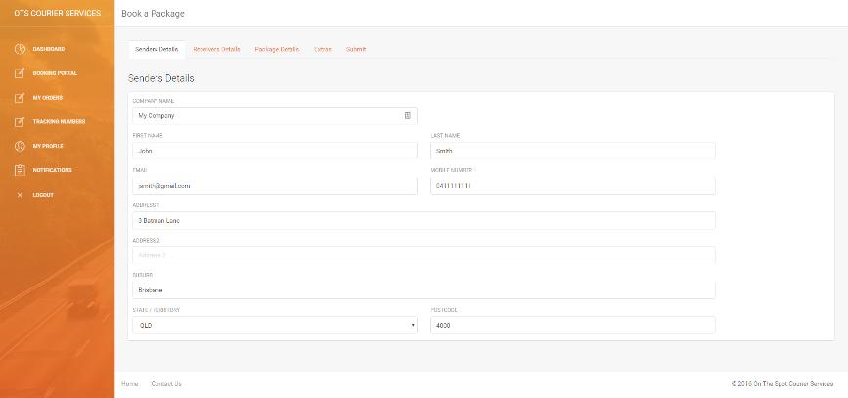

1:Senders Details Automatically Prefilled

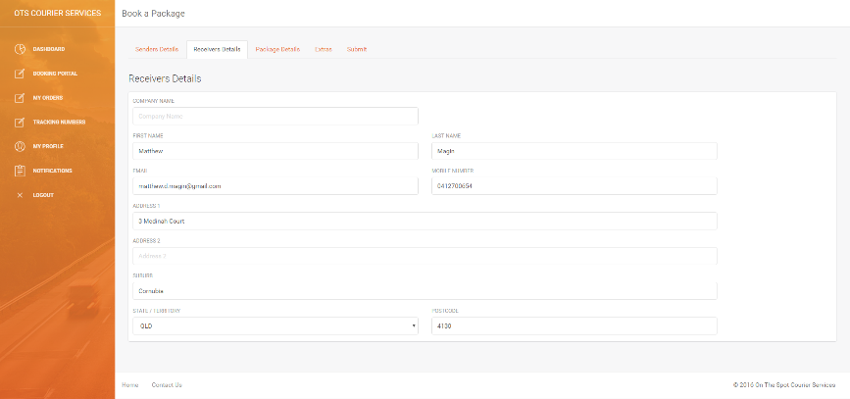

2:Receivers Details

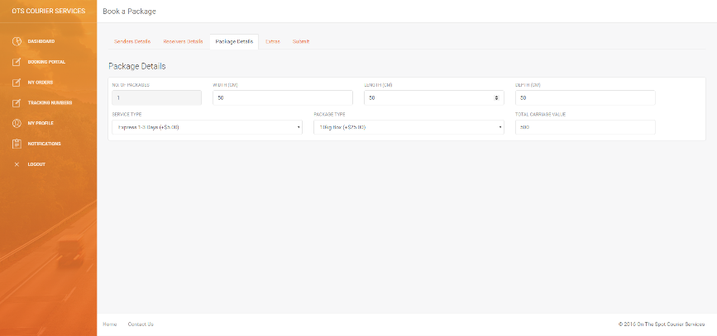

3:Package Details

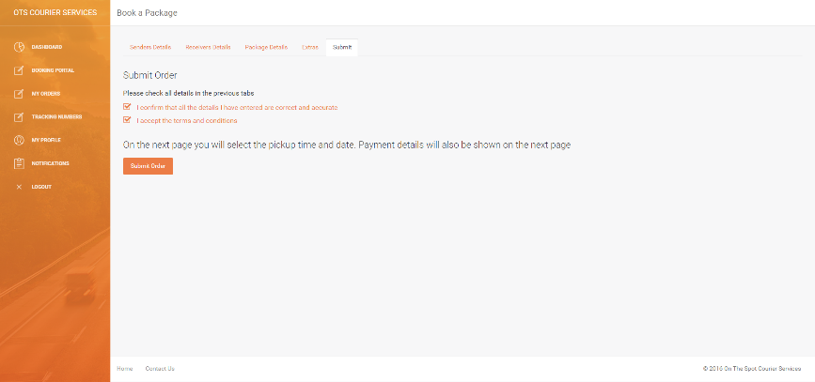

4: Confirmation Page

Expected Action/Result: After selecting the submit order button the user will be redirected to the submitrequestpickup.php page where they can select their payment type, see the payment amount and when the package will be collected.

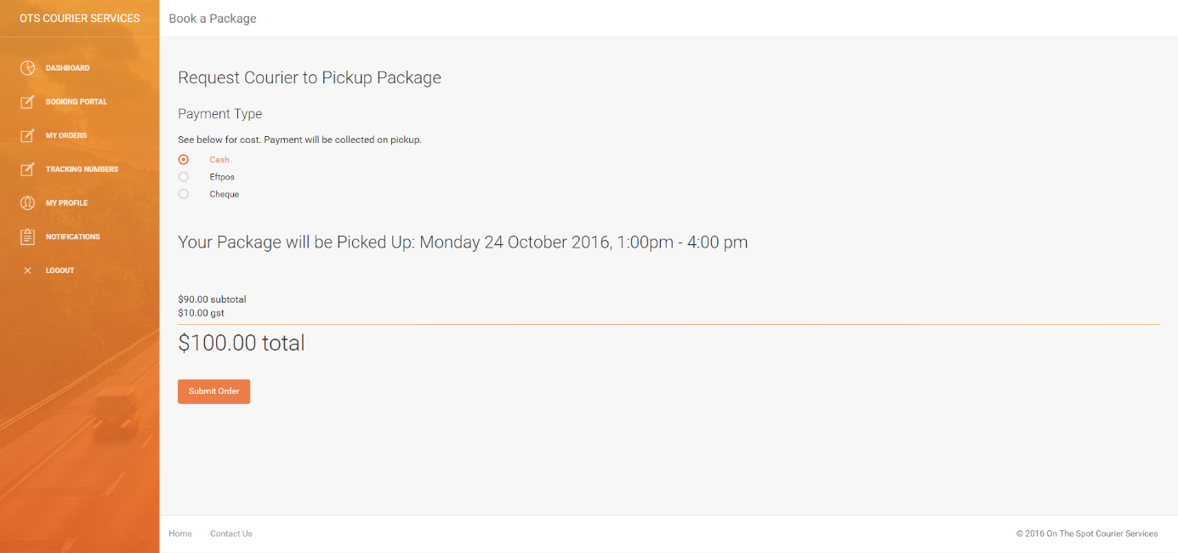

Expected Action/Result: After selecting the submit order button the user will be redirected to the bookingconfirmation.php page where they can see the booking/tracking number, see the full order, print consignment note and tax invoice (see above unit tests for viewing the order/ printing connote and tax invoice).

After returning to the dashboard: the packages pending count increments and the order appears under my orders.

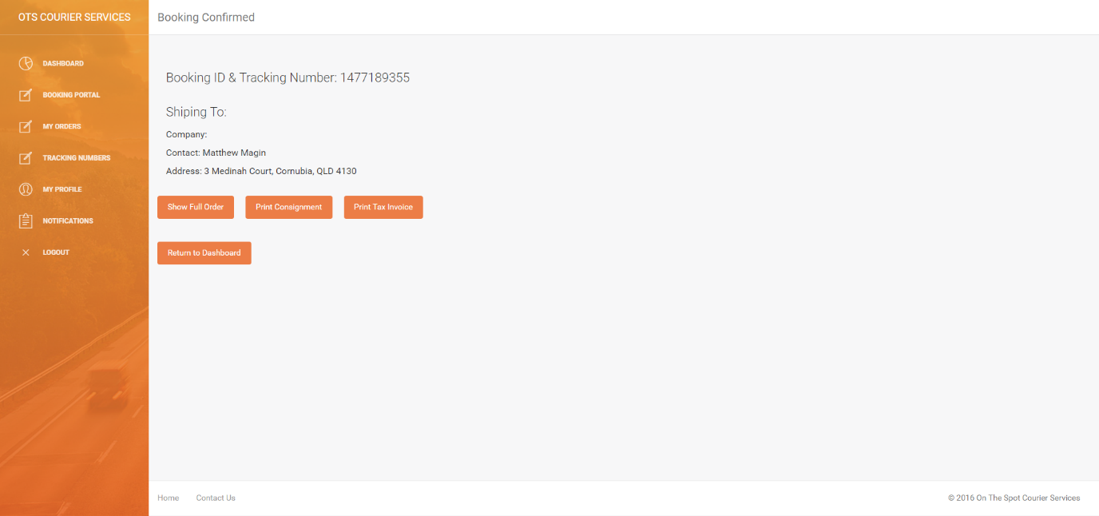

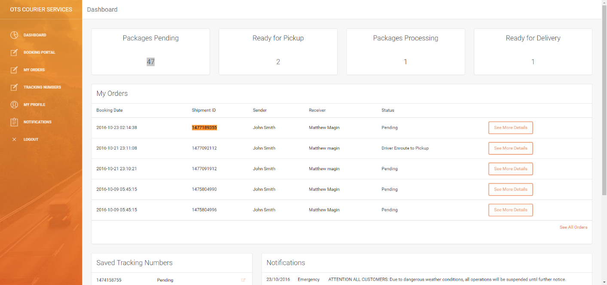

Expected backend output: The order appears in the bookings table, shipments table, payments table, and tracking table.

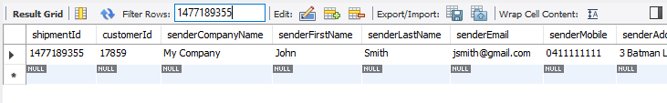

Bookings Table

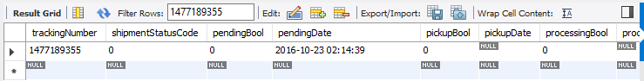

Shipments Table

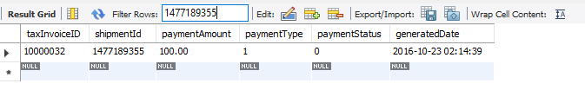

Payments Table

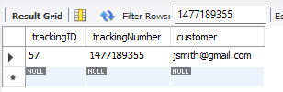  
Tracking Table (for saved tracking numbers)

**Test Successful – The test was successful because the booking was successfully added to the database and the coordinator can assign a driver from the coordinator portal.**

## Logging Out

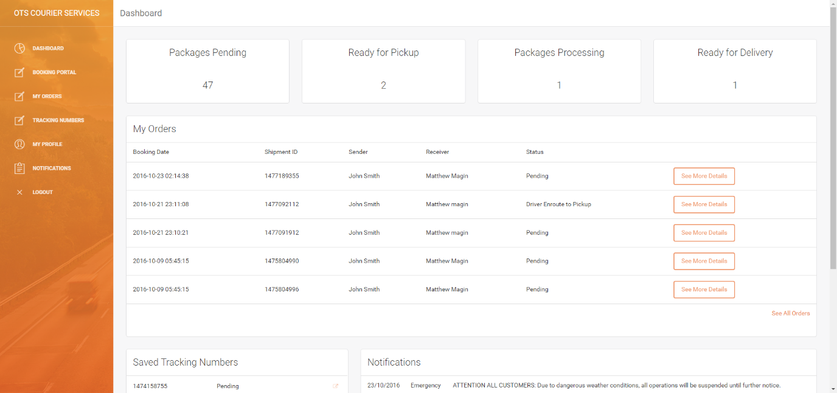

Expected Action/Result: After selected the logout button the user will be redirected to index.php. They will then need to login again the go back to the dashboard.

#### Output

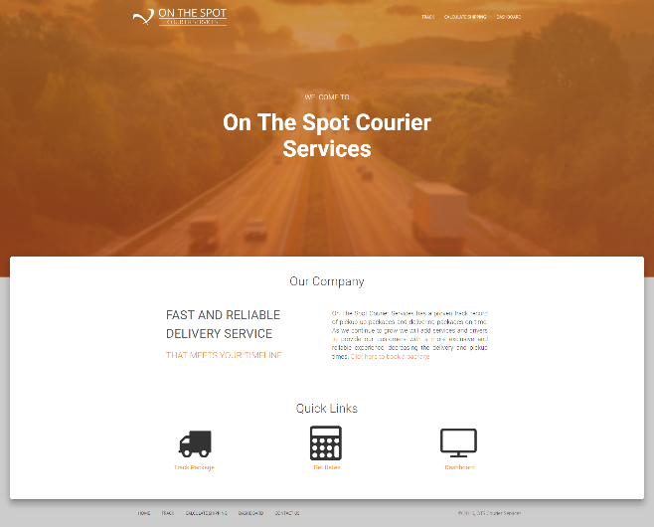



**Test Successful – The test was successful because the user was able to logout.**

## Driver Viewing/Changing Consignment Note/Shipment Information

#### Input Data

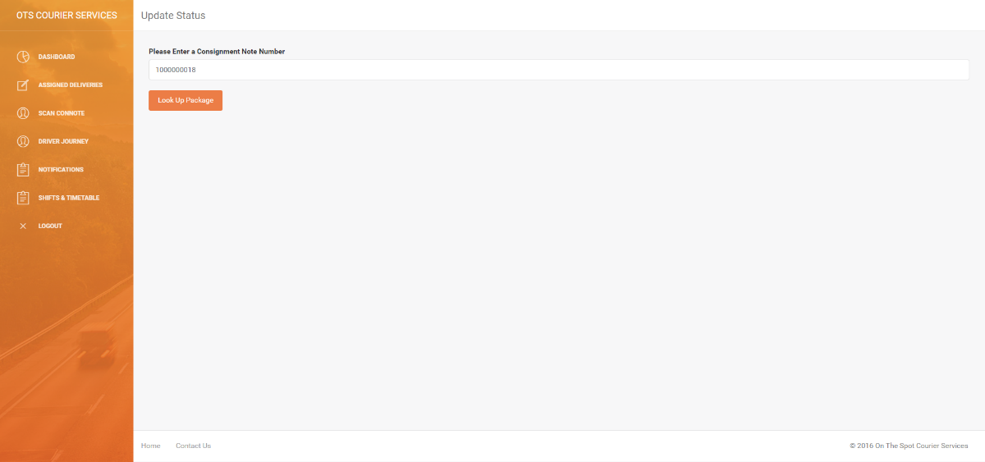

Expected Action/Result: After entering the consignment note number, the order details are pulled up.

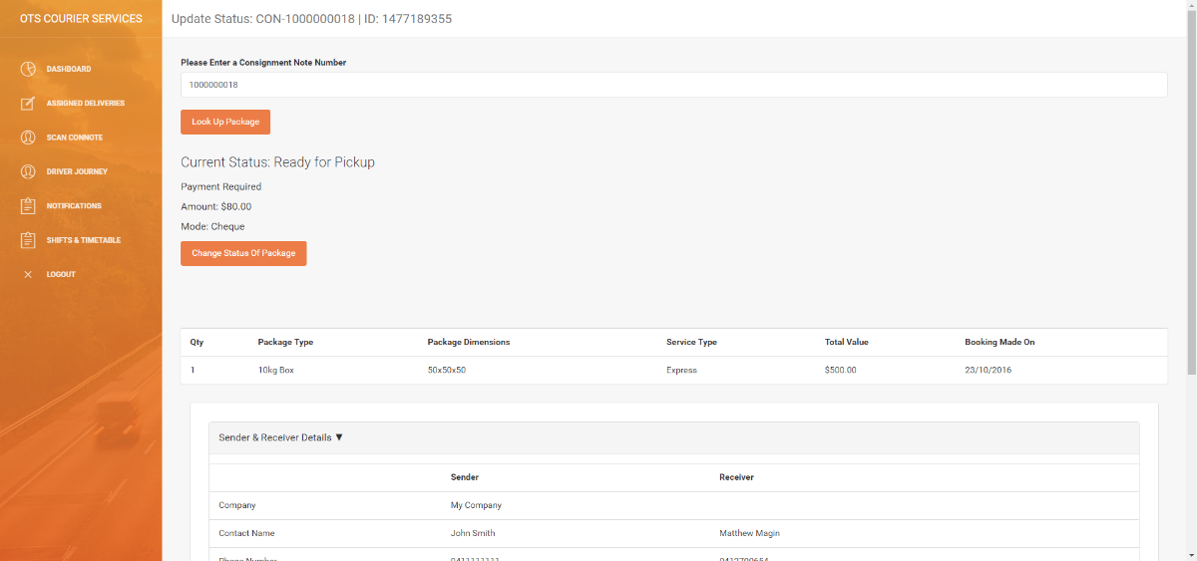

Expected Action/Result: After clicking ‘change status of package’ the driver can select the new status and submit it. Then the new status is reflected when the connote is pulled back up.

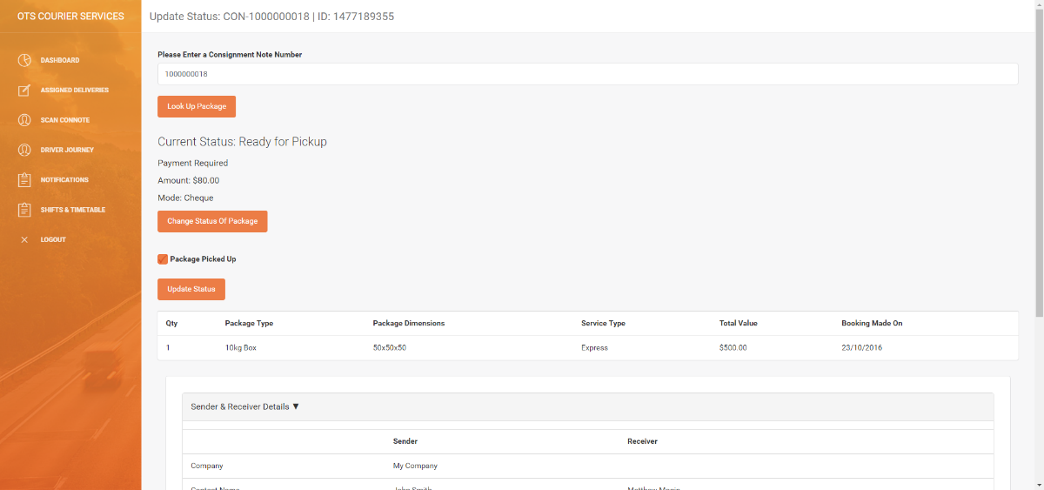

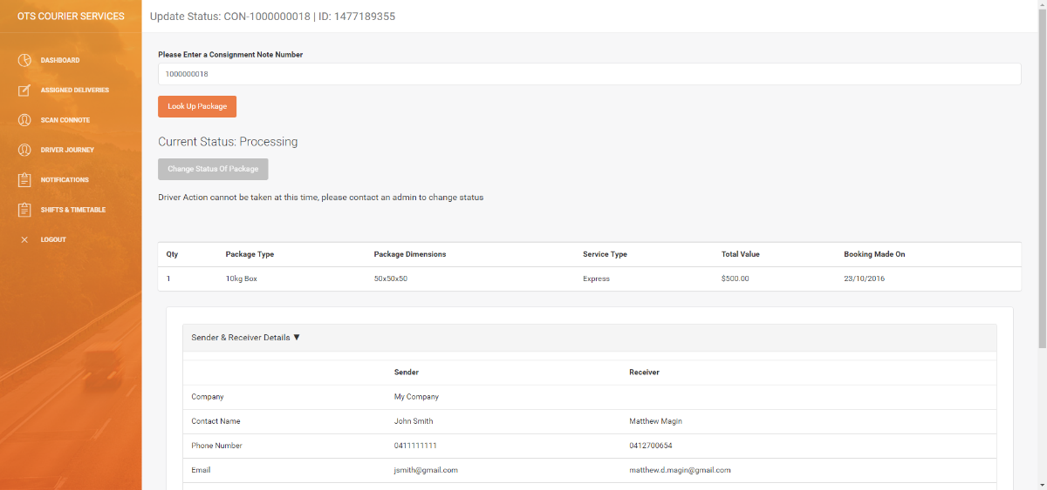

**Test Successful – The test was successful because the driver was able to view the order details and update the status successfully.**

## Driver Logging In

### Correct employee details

|  |  |
| --- | --- |
|  |  |
| staff/login.php original state | staff/login.php correct form data (credentials) entered |
| The Expected Result:  After correct form data is entered → submit button → page redirects to staff/driverDashboard/dashboard.php → Driver is logged in. | |

#### Output

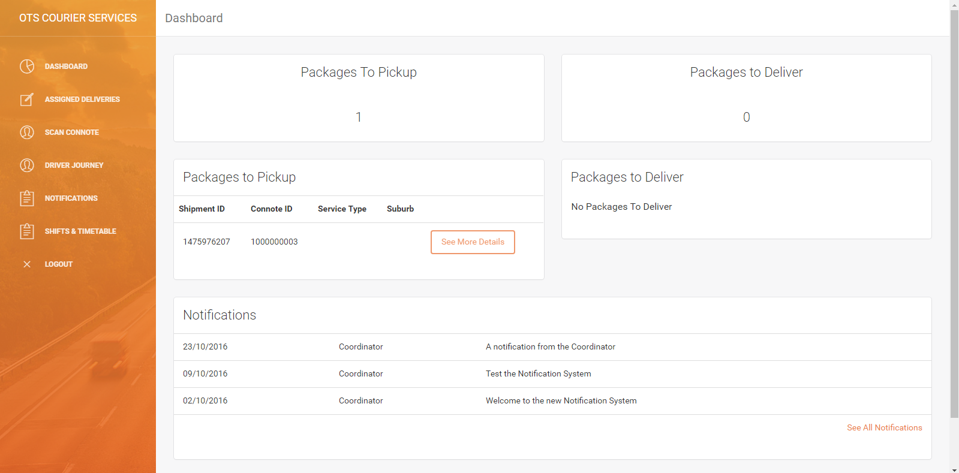

### Incorrect employee details

|  |  |
| --- | --- |
|  |  |
| staff/login.php original state | staff/login.php incorrect form data (credentials) entered |
| The Expected Result:  After correct form data is entered → submit button → page notifies user that the info is incorrect → User must enter other info | |

#### Output

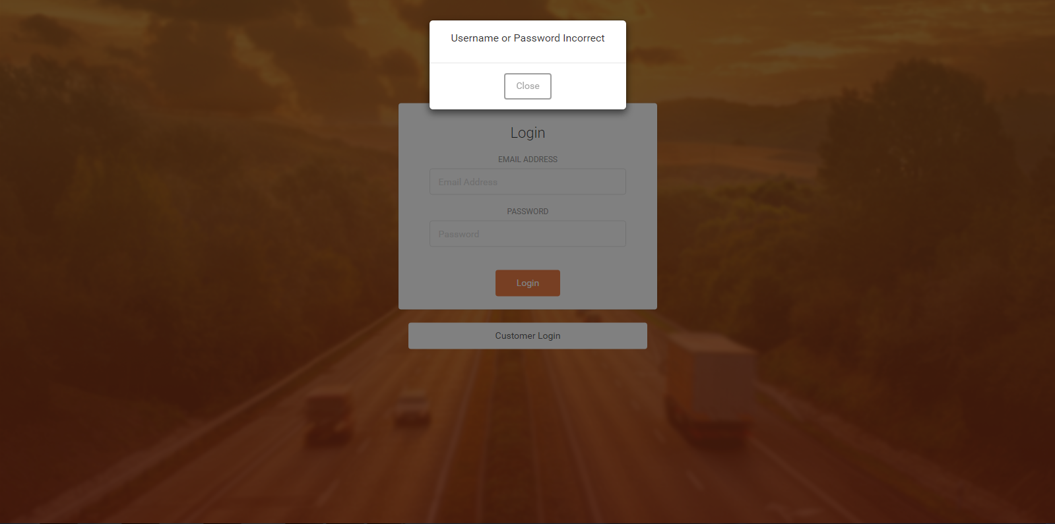

**Test Successful – The test was successful because the driver was able to enter their details and login to the account. Additionally, if the user enters incorrect data the user cannot login.**

## Coordinator Logging In

### Correct coordinator details

|  |  |
| --- | --- |
|  |  |
| staff/login.php original state | staff/login.php correct form data (credentials) entered |
| The Expected Result:  After correct form data is entered → submit button → page redirects to staff/coordinatorDashboard/dashboard.php → Coordinator is logged in. | |

#### Output

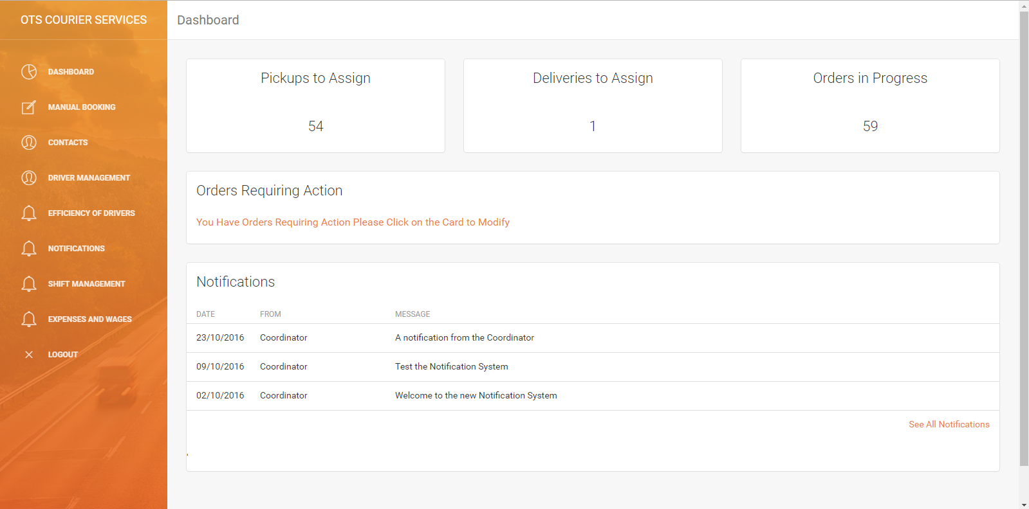

### Incorrect coordinator details

|  |  |
| --- | --- |
|  |  |
| staff/login.php original state | staff/login.php incorrect form data (credentials) entered |
| The Expected Result:  After correct form data is entered → submit button → page notifies user that the info is incorrect → User must enter other info | |

#### Output



**Test Successful – The test was successful because the coordinator was able to enter their details and login to the account. Additionally, if the user enters incorrect data the user cannot login.**

## Viewing Contacts

### Click Contacts

|  |  |
| --- | --- |
|  |  |
| The Expected Result:  The web browser navigates to the contacts page and displays a list of contacts | |

#### Output

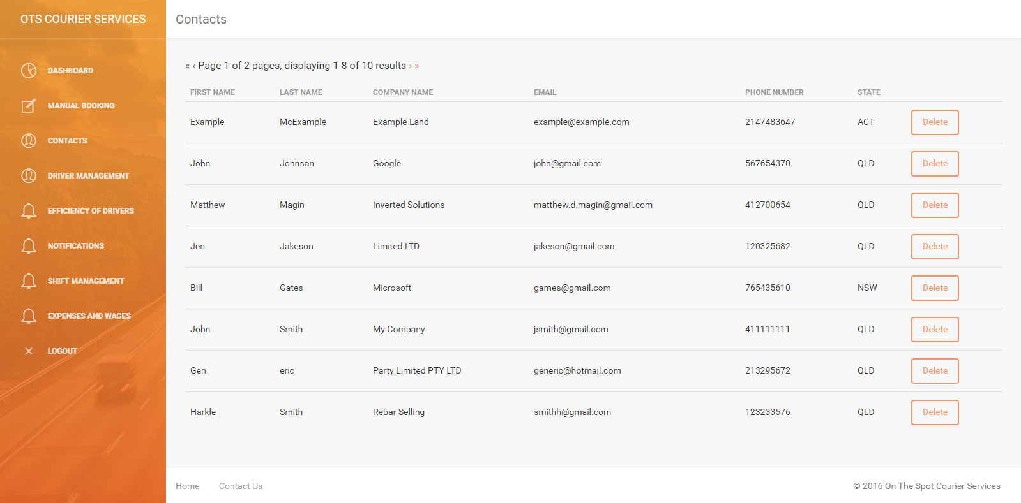

### Click Individual Contact

|  |  |
| --- | --- |
|  |  |
| The Expected Result:  The web browser navigates to the contact’s individual page and displays its info | |

#### Output

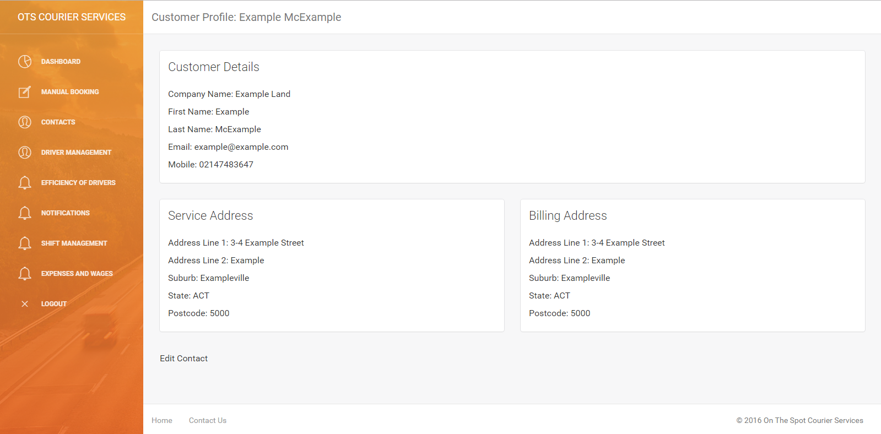

**Test Successful – The test was successful because if the coordinator clicks on the contacts button, it will show them the list of contacts, and when they click an individual contact it will display specific individual info.**

## Deleting Contacts

### Deleting a contact (Yes)

|  |  |
| --- | --- |
| Click the delete button for a contact |  |
| The Expected Result:  The web browser navigates to the contact’s individual page with a prompt for deletion | |

#### Output

Click “Yes” to delete

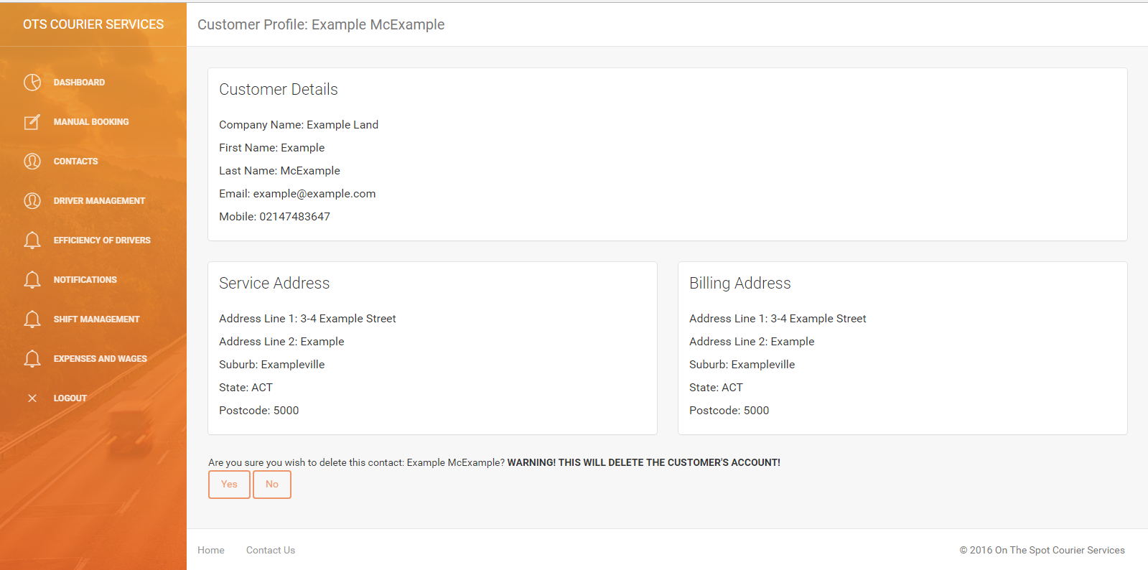

The Expected Result:

The customer’s entry in the database is deleted and the web browser will navigate back to a list of contacts where the customer will no longer appear

#### Output

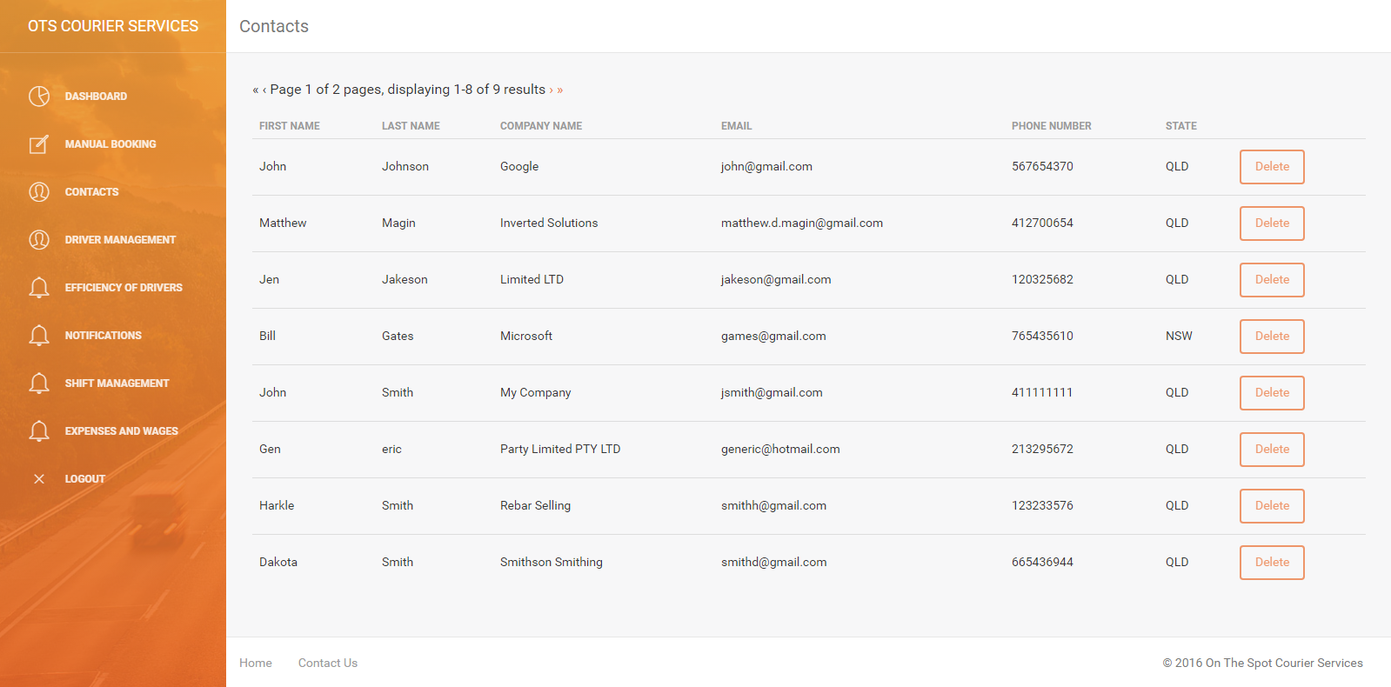

**Test Successful – The test was successful because the contact was deleted.**

### Deleting a contact (No)

|  |  |
| --- | --- |
| Click the delete button for a contact |  |
| The Expected Result:  The web browser navigates to the contact’s individual page with a prompt for deletion | |

#### Output

Click “No” to avoid deletion



The Expected Result:

The customer’s entry in the database is not deleted and the web browser will navigate back to a list of contacts where the customer will still appear

#### Output

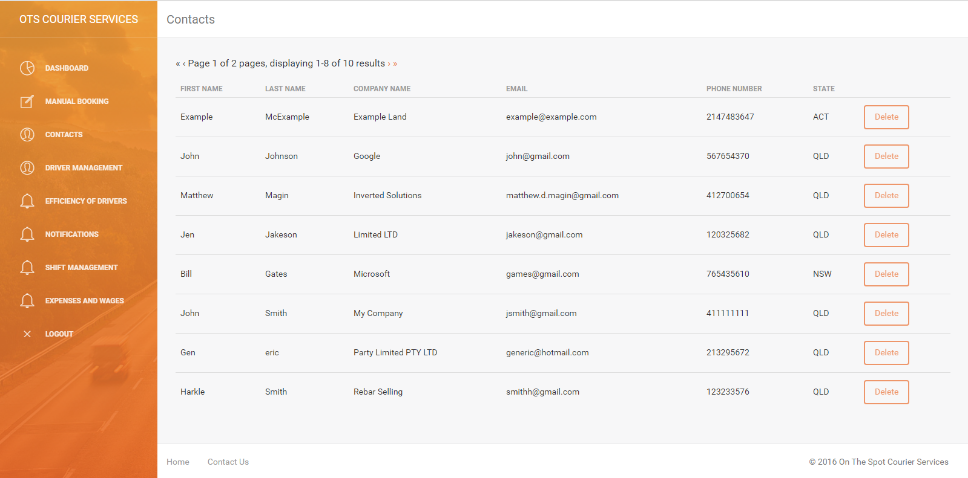

**Test Successful – The test was successful because the contact was not deleted and can still be seen.**

## Viewing Deliveries

### Click Deliveries

|  |  |
| --- | --- |
|  |  |
| The Expected Result:  The web browser navigates to the deliveries page and displays a list of deliveries assigned to the logged in driver | |

#### Output

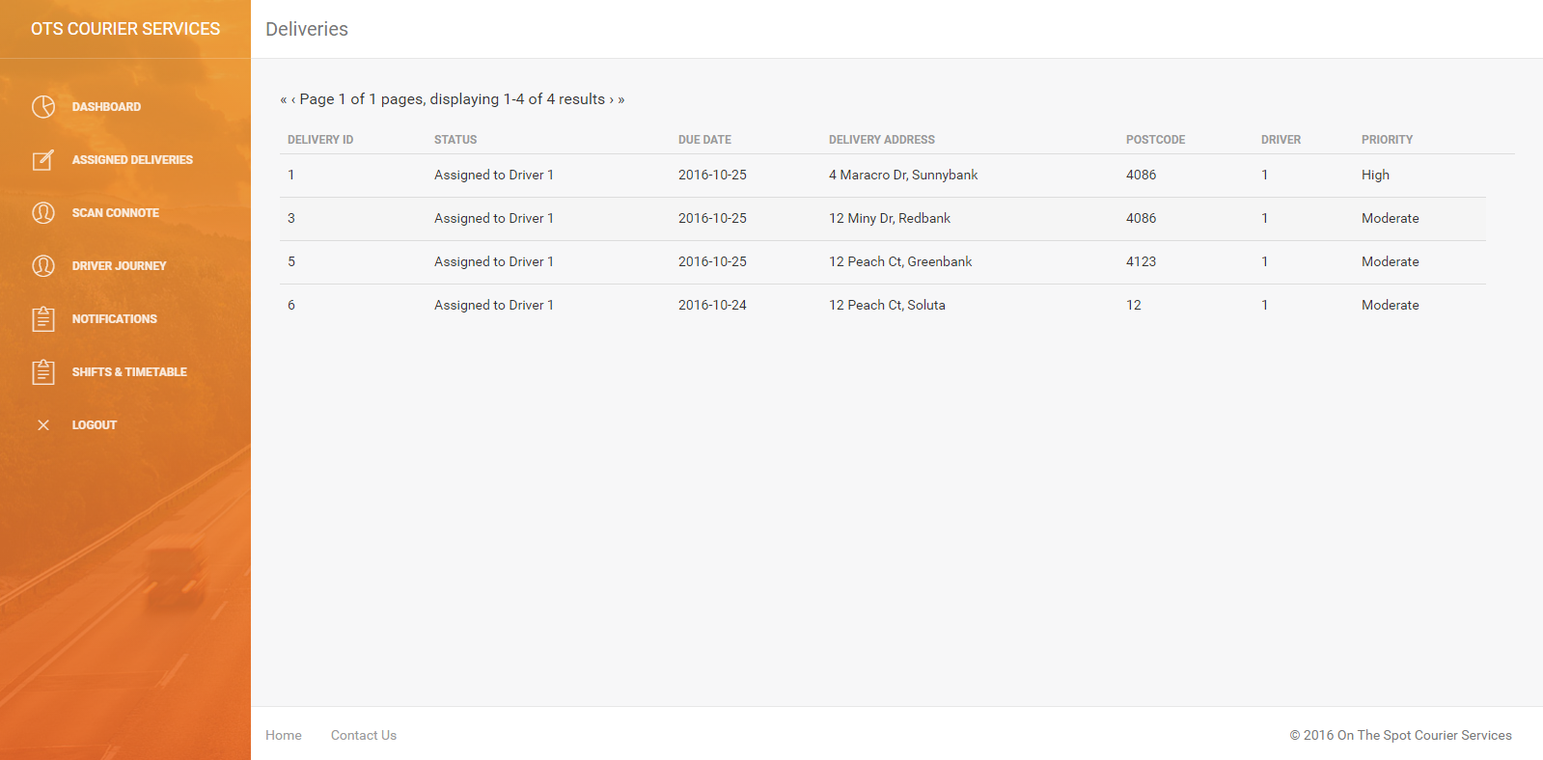

**Test Successful – The test was successful because the driver is shown a list of deliveries assigned to them and no one else.**

## Send Coordinator Notification

### Sending Notification

|  |
| --- |
|  |
| Expected Result: After typing in a message into the notification box, selecting the notification type as “Coordinator Message”, the recipients and hitting the “Send Notification” button, the page sends the notification, which is then present on the notifications page as a Coordinator notification. |

### Output

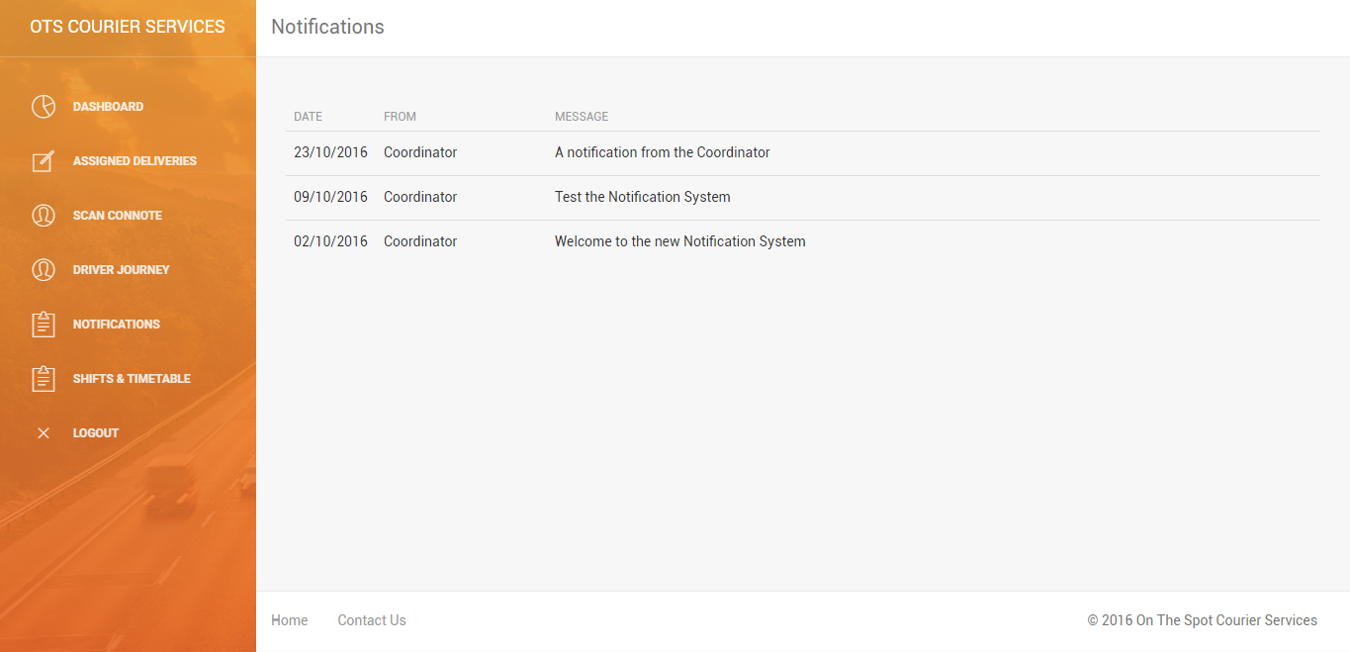

**Test Successful – The test was successful because the new Coordinator notification was correctly received and displayed by the recipient's notification page.**

## Send Emergency Notification

### Sending Notification

|  |
| --- |
|  |
| Expected Result: After typing in a message into the notification box, selecting the notification type as “Emergency Message”, the recipients and hitting the “Send Notification” button, the page sends the notification, which is then present on the front dashboard page as an Emergency notification. |

### Output:

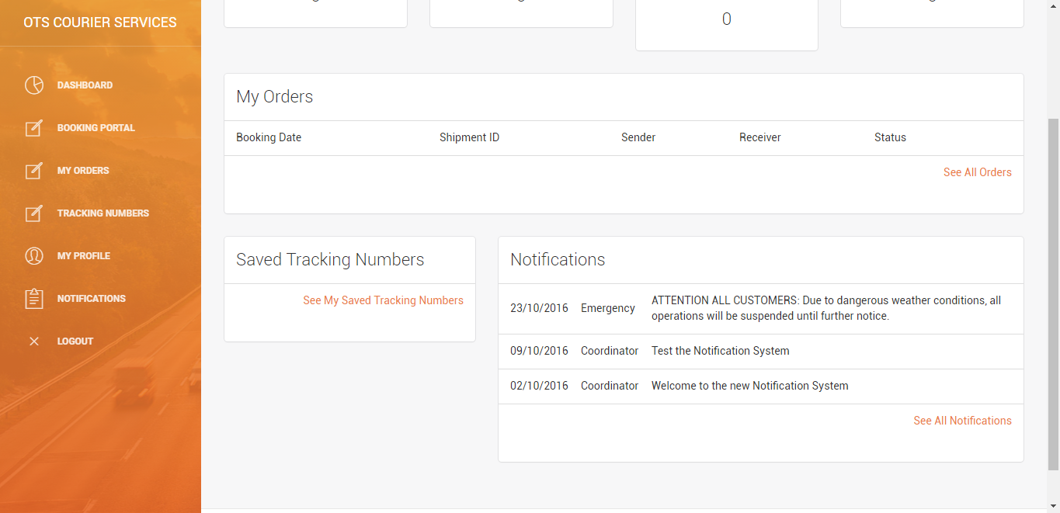

**Test Successful – The test was successful because the new emergency notification was correctly received and displayed on the recipient’s dashboard page.**

## Assign Package to Driver

### Assignment Page

|  |
| --- |
|  |
| Expected Result: On the Package Assignment Page, once an option is selected from the Assign Driver drop-down box for a delivery, that driver is assigned to that delivery, and all information pertaining to that delivery, such as the shipment status, should change to reflect that. |

### Output:

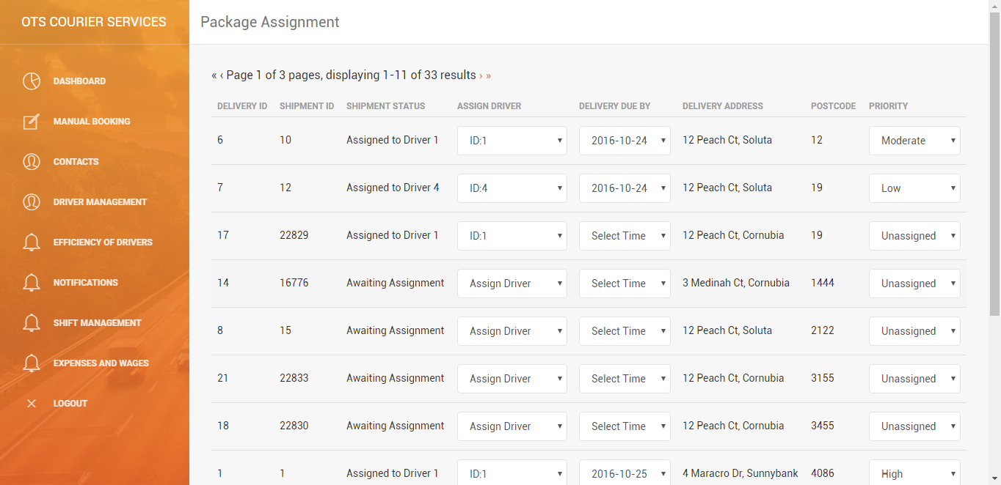

**Test Successful – The test was successful because once the Driver ID was selected from the drop-down box, the shipment status correctly changed to indicate that package seventeen was now assigned to Driver One.**

## Assign Package a Delivery Date

### Assignment Page

|  |
| --- |
|  |
| Expected Outcome: On the Package Assignment page, for any delivery, the delivery date can be assigned via selecting an option from the “Delivery Due By” column. Once selected, this date is assigned as the set delivery date for this package and is displayed as such, including being present on the daily timetable. |

### Outcome

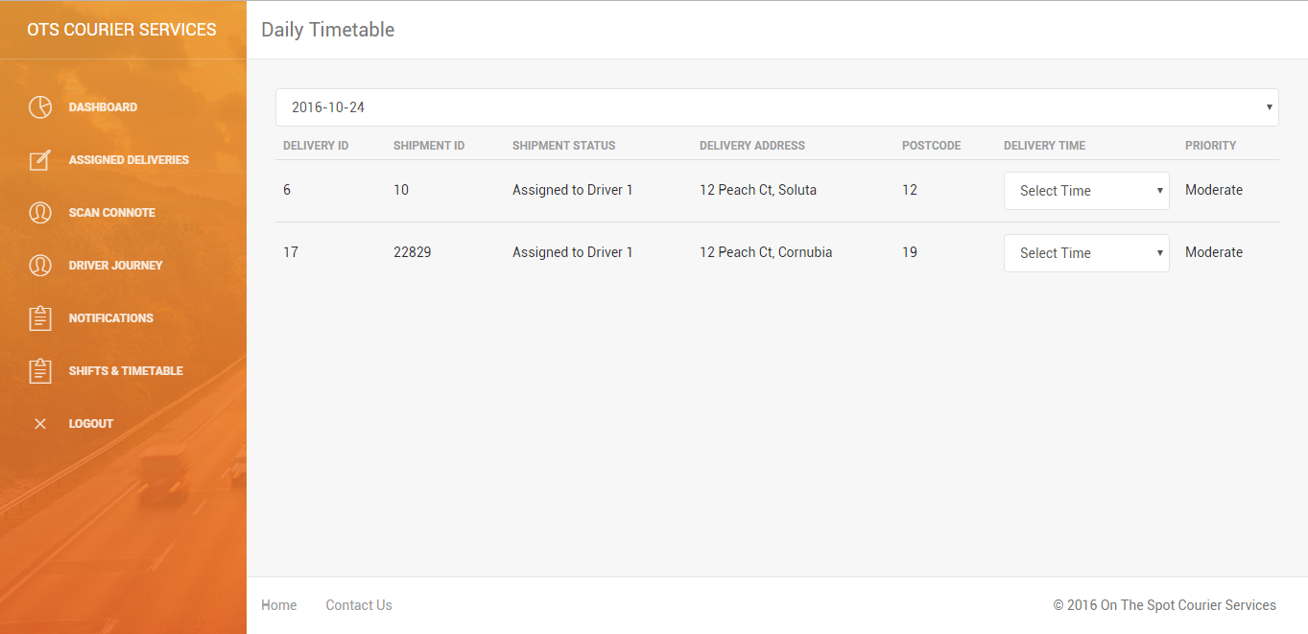

**Test Successful – The test was successful because once the delivery time was selected for the package with Delivery ID 17, that it appeared on the assigned driver's Timetable on that date.**

## Assign Package Priority

### Assignment Page

|  |
| --- |
|  |
| Expected Result: On the Package Assignment page, for any delivery, an option to assign a level of priority can be selected from the “Priority” drop-down box for any delivery. Once a priority level is selected for that package, it is visible on other pages, such as the assigned deliveries page. |

### Output:

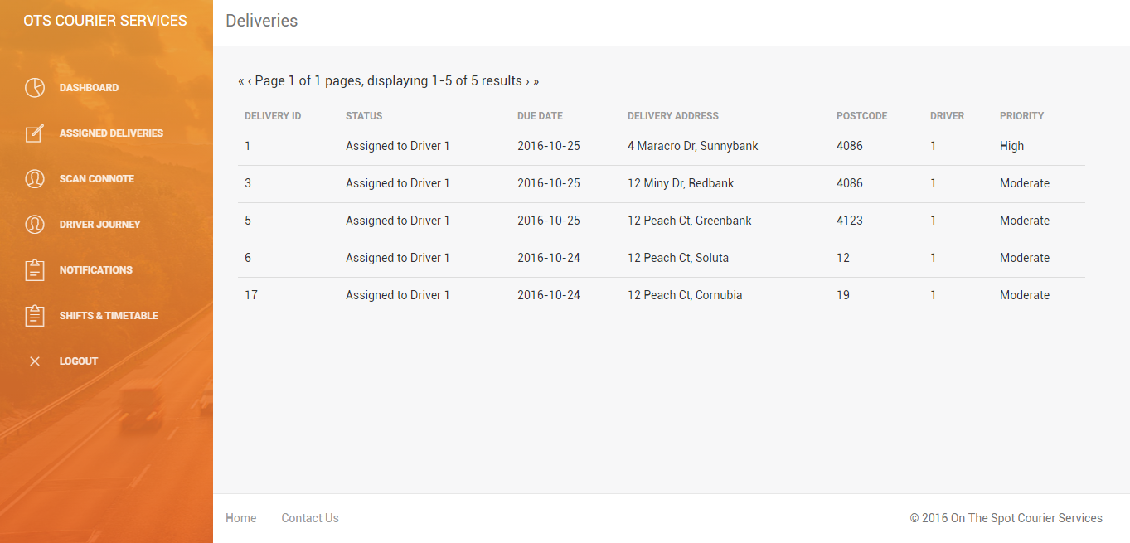

**Test Successful – The test was successful because once the priority for the package was selected for the package with Delivery ID 17, the change was reflected around the site under the priority column.**

## Assign Delivery a Delivery Time

### Daily Timetable

|  |
| --- |
|  |
| Expected Result: On the Daily Timetable page, on the day which in the delivery has been assigned, the delivery time can be selected through the “Delivery Time” drop-down box. Once a time is selected, that delivery time is assigned to that package. |

### Output:

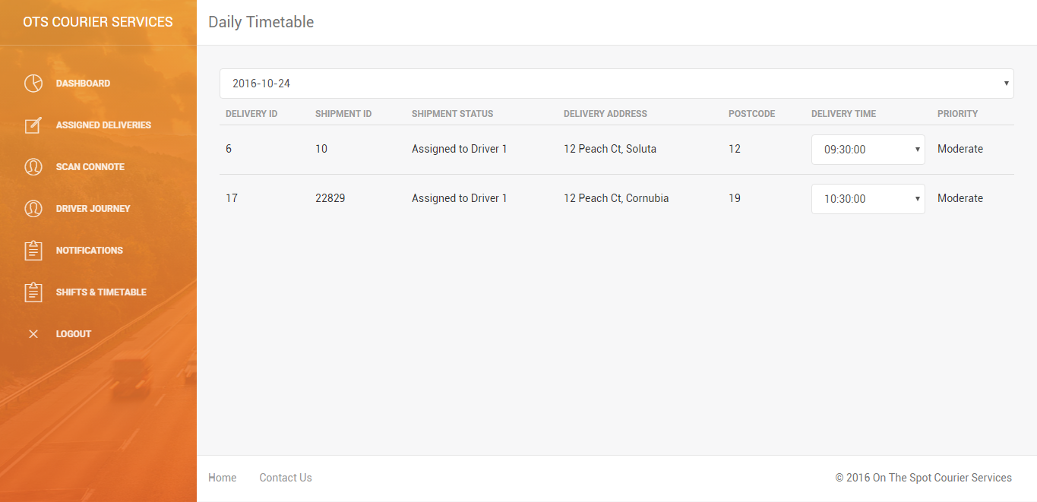

**Test Successful – The test was successful because once the delivery time was assigned for an individual package, the page updated to reflect that.**